Kelompok 8 :

- Abdullah Azzam (1301174360): Soal No.1

- Haris Saputra (1301174227): Soal No.2 & 3

- Salman Rachmadi (1301174440): Soal No 5

- Jaish Muhammad (1301174542): Soal No 4

1. Terbesar

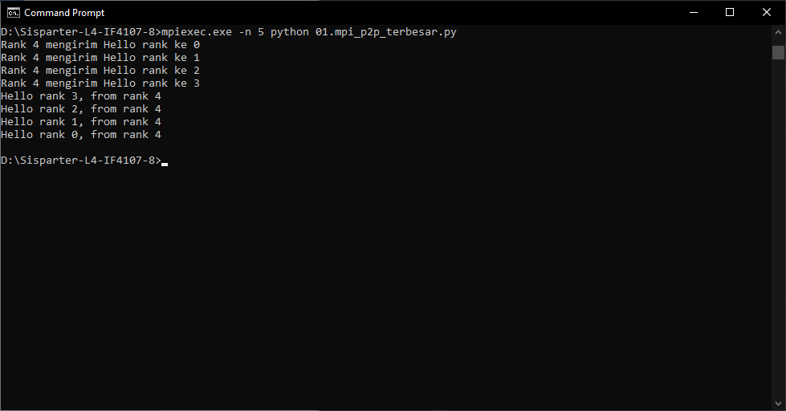

1.Terkecil

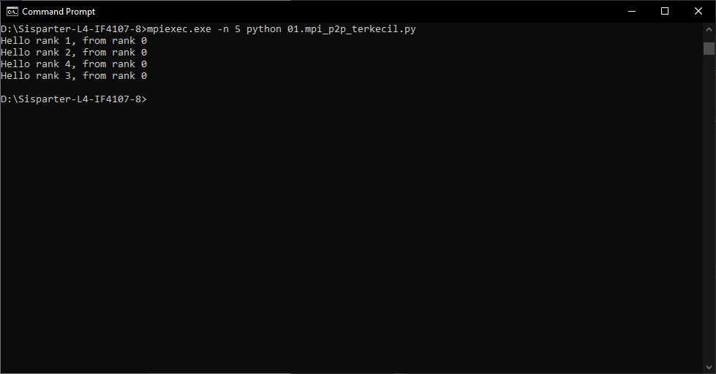

2. Broadcast

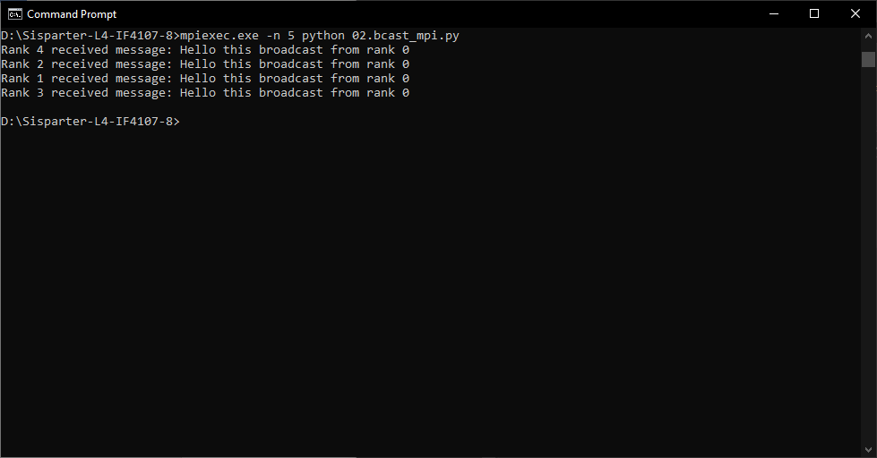

3. Sum

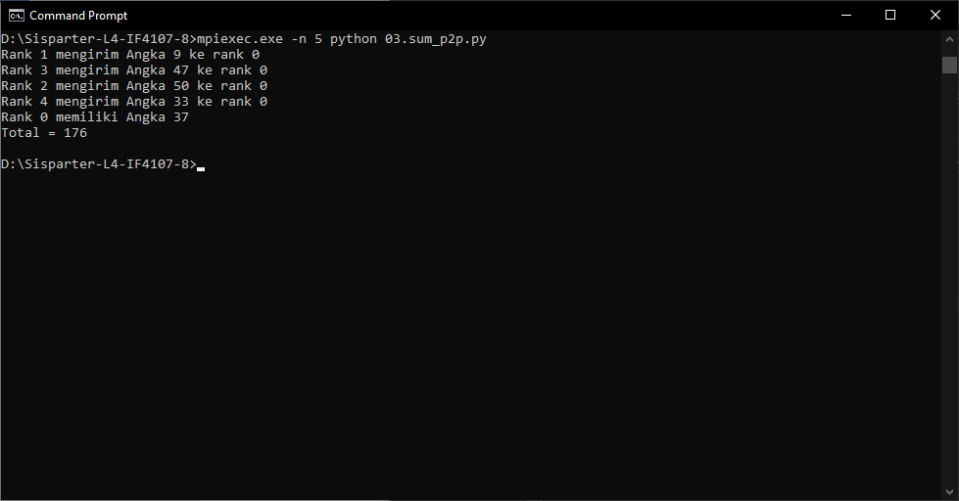

4. Sum Reduce

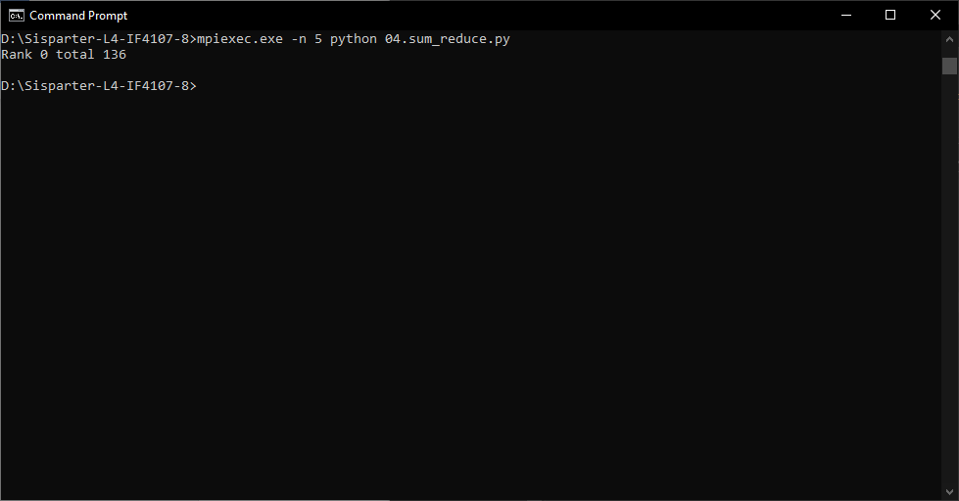

5.1 MPI pi

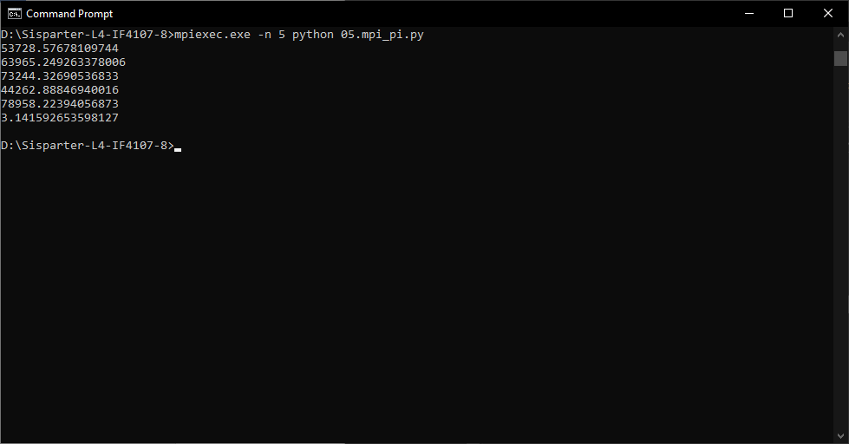

5.2 Serial pi